**CRC 3 Documentation Fall 2021**

**By Seiyon Arulampalam**

**Contents**

**Overview** **1**

**Hardware and Components** **1**

**3D Printing Brackets and Connections** **1**

**Building the Wings** **4**

**Assembling Electronic Components** **4**

**Flashing the Firmware onto the Board** **6**

**Testing Motor Function** **7**

**Setting up the RC Controller to control the motors** **10**

**VOXL Flight - Controller + Computer** **11**

**Wireless Connection between QGC and VOXL** **11**

WiFi Connection Process 13

**Telemetry** **14**

# Overview

The project's expected outcomes include flight testing or demonstrating the aircraft's functionality, complete documentation of the software, hardware, operation of the entire system. In addition, the team will be working on circuit design, programming, control aspects, and mechanical part fabrication of the CRC-3.

# Hardware and Components

Link to Build of Materials Spread Sheet:

Reasons for Choosing Certain Components:

1. **VOXL Flight**: Single PCB that contains both the flight controller that runs PX4 and the companion computer that has the capabilities of running experimental algorithms.
2. **Matek PDB**: Must be used to distribute power to the motors and electronic speed controllers (ESCs).
3. **HOBBYMATE D6 Duo Pro Balance Charger Dual Ports**: The reason for the purchase is that it has many built in safety features that allow the user to monitor the health of the battery.

# 3D Printing Brackets and Connections

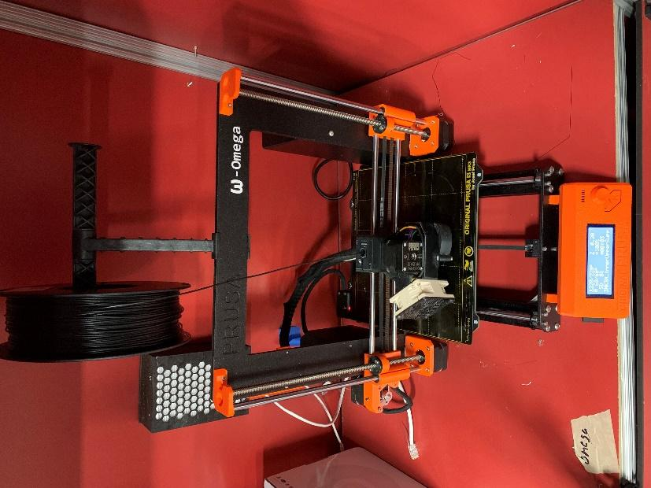

Figure 3.1

The printer used for manufacturing the brackets is the Original Prusa i3 MK3S+ located at the Forge center in RPI.

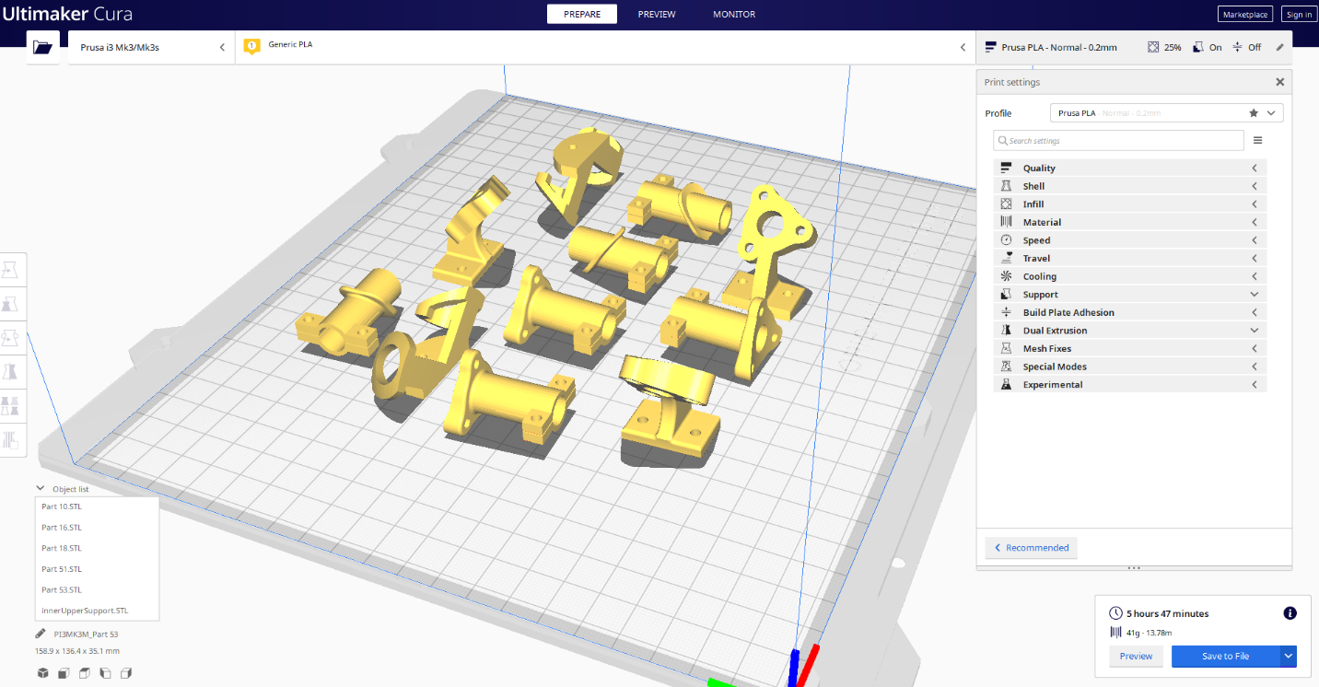

Figure 3.2

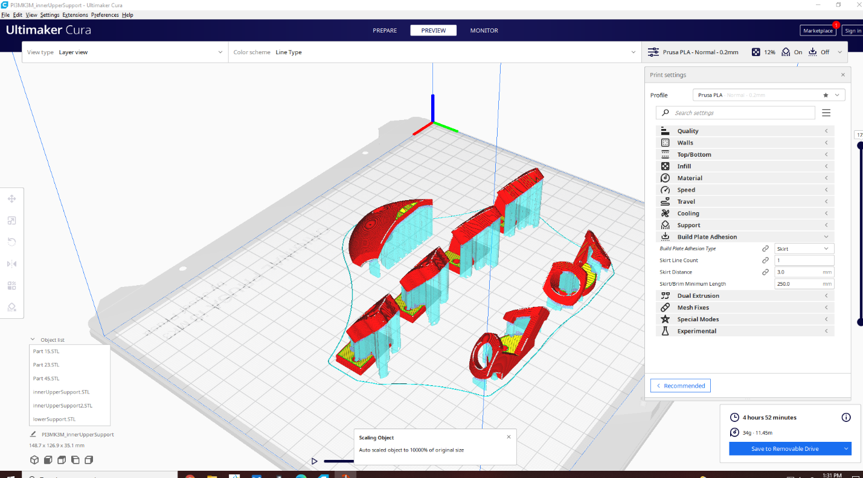

Figure 3.3

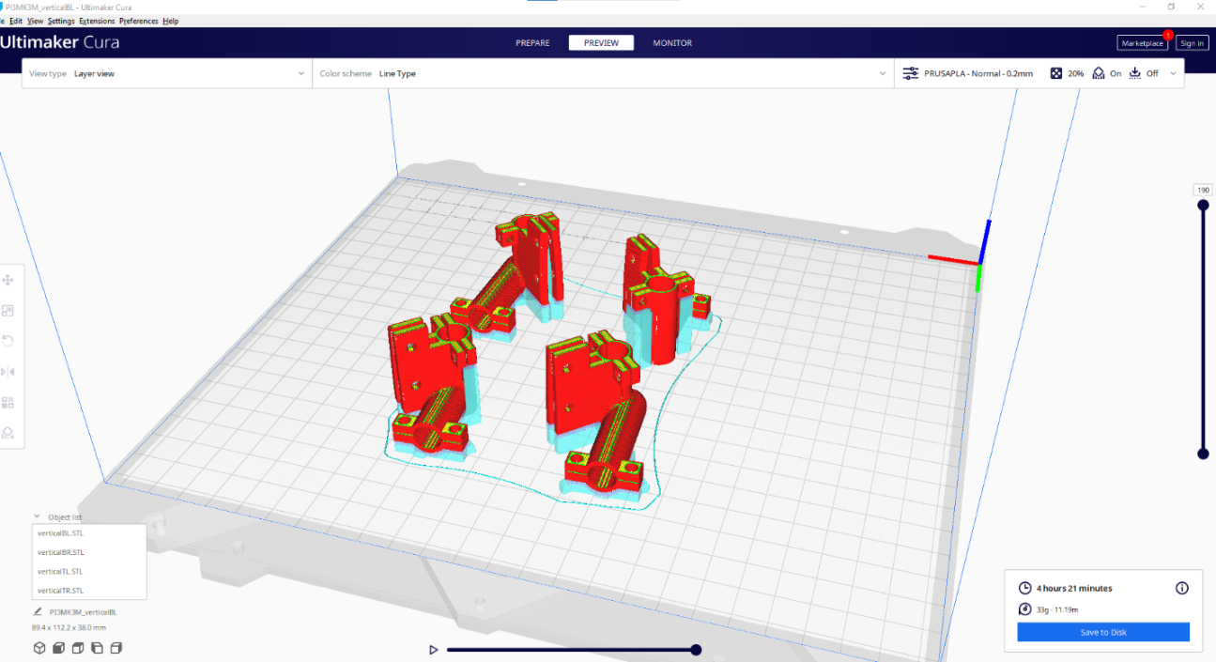

Figure 3.4

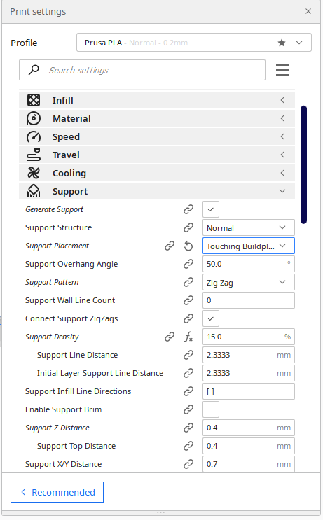

Figure 3.5

When 3D printing the structures, the group concluded that it was disadvantageous to have supports inside the tubes. Having support structures within the tubes made it extremely difficult to remove cleanly. Therefore, when 3D printing the brackets it is strongly advised that the user goes to the tab labeled “support” and set “support placement” as “Touching the Buildplate”. Also take into account the bending direction of the specific bracket in the orientation of the bracket on the build plate. The layers of the print should be aligned parallel to the direction of the tubing. Layering so that the tube part of the bracket is pointing vertically from the build plate may make it more susceptible to breaking during post-processing or flight/landing.

# Building the Wings

A pure foam wing was deemed not rigid enough for flight, so using a balsa core was necessary. Below are the steps to building the wings:

1. Starting with the wing, a 1” (or any similar thickness will work) thick polystyrene foam board large enough to fit 20 cutouts of the desired airfoil shape side-by-side is needed
2. In the CAD folder of this directory there should be a .dxf file named “WingXSolid.dxf”.
   1. If the file exists, skip this subsection. If not, continue reading.
      1. Open the wing CAD part file in NX and export it as a parasolid (.x_t file extension)
      2. Note that any edits to the airfoil are done in NX
      3. For example, if you want to change the filet radius of the trailing edge, simply select the filet feature of that part in NX and change the dimension
      4. Open the parasolid file in SolidWorks and select save as in the menu bar at the top
      5. Choose to Save As a “.dxf” file
      6. Select the view that shows the airfoil shape and save as a .dxf to a usb drive
3. At the RPI forge, ask for help with the laser cutter, especially for turning on the machine and the filtration system.
   1. Open the laser cutter application on the computer next to the laser cutter
   2. Drag and drop the .dxf file onto the laser cutter application sheet
   3. Delete anything that isn’t the airfoil shape.
   4. Copy and paste the airfoil shape as many times as you need but I suggest doing a test cut on a single airfoil first
   5. They should show you these steps but here they are anyway,
      1. Place the foam board on the grate
      2. Use the arrows on the console to move the laser around to the desired starting point
      3. IMPORTANT: Usually there’s a specified distance the laser should be from the surface of the board, but in order to get a good cut place the laser as close to the board as possible without touching it. Otherwise it won’t cut all the way through and increasing power or decreasing speed will melt the foam on the backside of the cut.
      4. Press origin on the console to set the start point corresponding to the origin on the computer screen
      5. Secure the board down with the magnets on the cutter
      6. Close the door to the cutter
   6. Set the cutter speed to 25 and the power to 10%
   7. Press “Start”
4. After the cut is complete, remove all the cutouts and the material left in the core cutout.
5. Cut the balsa wood core
   1. Buy a 1/16” balsa wood sheet (the RPI bookstore has these)
   2. Create a rectangle in CAD of the proper dimensions or use the .dxf file named “WingSpar.dxf” in the CAD folder of this directory
   3. Repeat the same process as above for using the laser cutter
      1. IMPORTANT: For the balsa wood, use the laser focus to set the laser height
      2. There is a guide sheet on the Forge computer to set the laser speed and power
6. Slide each of the airfoil cutouts onto the balsa wood core one by one putting gorilla glue between each piece and squeezing them together for 30 seconds each time.
   1. Let the glue dry once done and sand down all foam surfaces to get the desired finish
7. Measure out enough monokote to cover a little more than the whole wing
   1. Wrap the wing in monokote and slowly adhere it by using a normal clothing iron
   2. Cut off any excess monokote

# Assembling Electronic Components

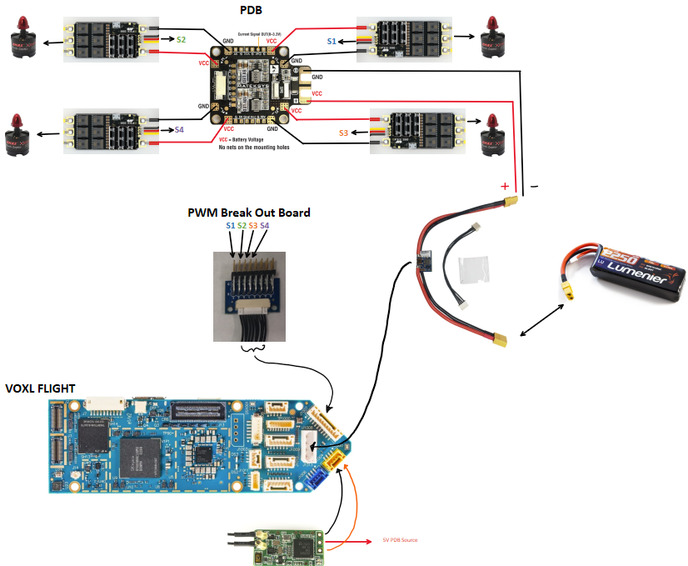

Wiring Guide Figure 4.1

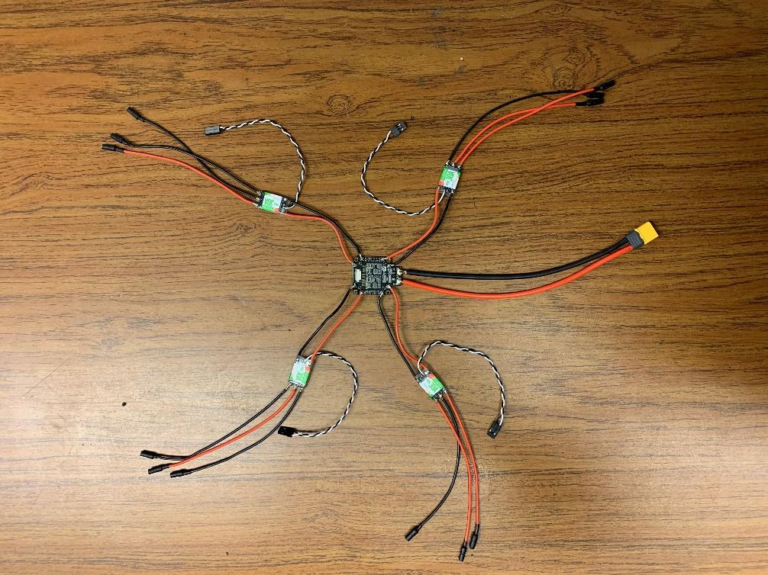

Figure 4.2

Figure 6.2 displays the implementation of the power distribution board (PDB) with the electronic speed controllers (ESCs). The purpose of the PDB is to distribute power from the LIPO battery to all 4 motors.

The yellow connector is the XT60 connector. Its purpose is to connect to the LIPO battery to the PDB. Each ESC has 3 lead wires with a 3.5mm bullet connector soldered to the end. The bullet connectors are used to connect the motors to the ESC.

In order to make sure there were no short circuits created during the assembly process a multimeter was used to ensure there was no continuity. The symbol for continuity symbol on a multimeter is shown in Figure 4.3 below.

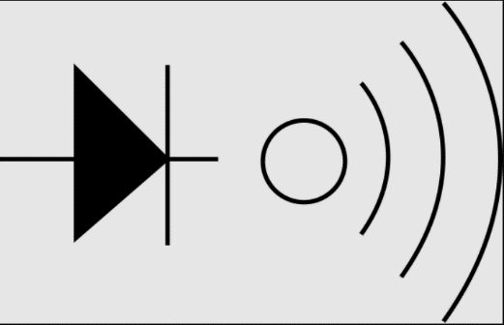

Figure 4.3

The next step is to test each ESC and motor to ensure there are no manufacturing errors from the vendors. The test procedure is to iteratively plug in each motor to each ESC one at a time and then plugging the LIPO battery to the XT60 connector. Once the batter has been plugged into the PDB, there should be a beep sound from the ESC and the motor should move very slightly. If the motors do not move on the first try, unplug the battery, and then spin the motor about its axis to change the location of the magnets. Then retry plugging the battery into the system.

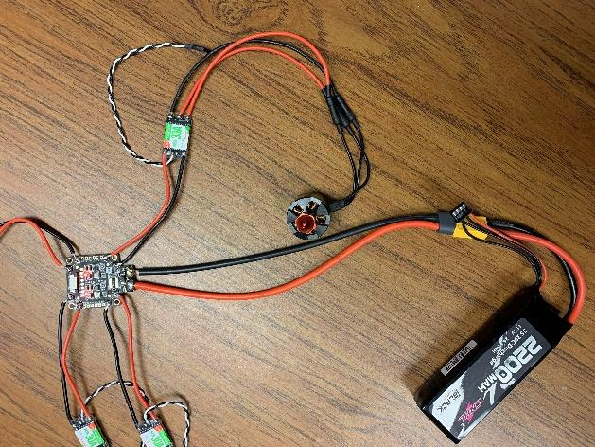

Figure 4.4

Figure 4.4 shows an example of connecting the LIPO battery, PDB, ESC, and Motors.

# Flashing the Firmware onto the Board

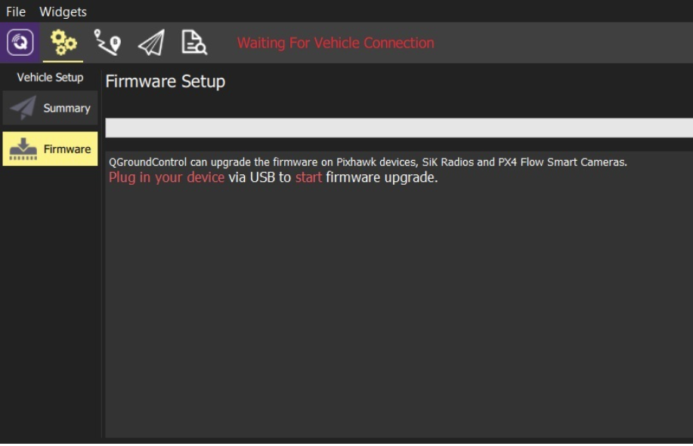

Figure 5.1

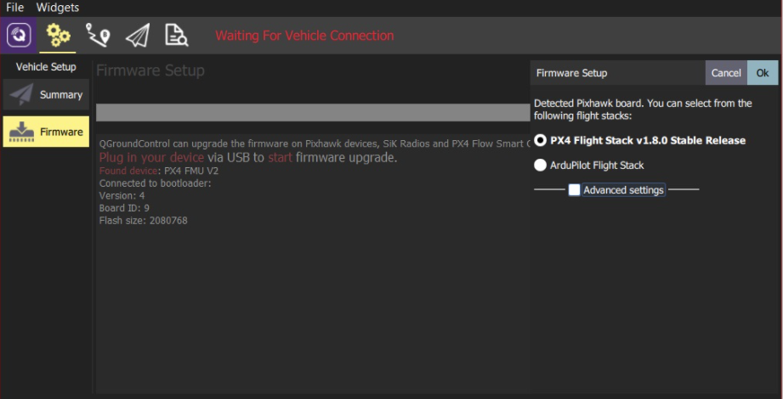

Figure 5.2

Select PX4 Flight Stack Stable Release and then “OK.”

During the upload, I kept the LIPO plugged in because the usb power was not enough to power the flight controller. There might be an error message saying that the LIPO battery must be removed. Ignore it.

Unplug the flight controller from the computer and power cycle it. Then plug it back into the QGC software.

# Testing Motor Function

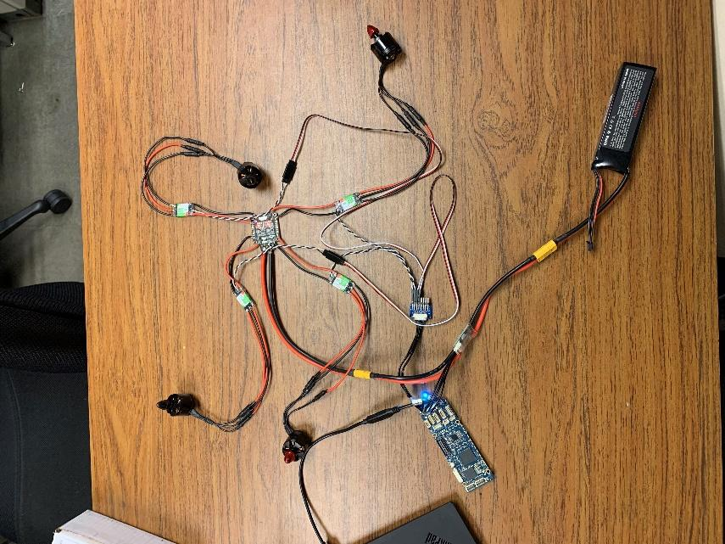

Figure 6.1

Figure 6.1 displays the physical wiring of the system based on the wiring diagram from Figure 4.1 in section 4.

In order to test the motor, I selected the stock “Quadrotor x” airframe.

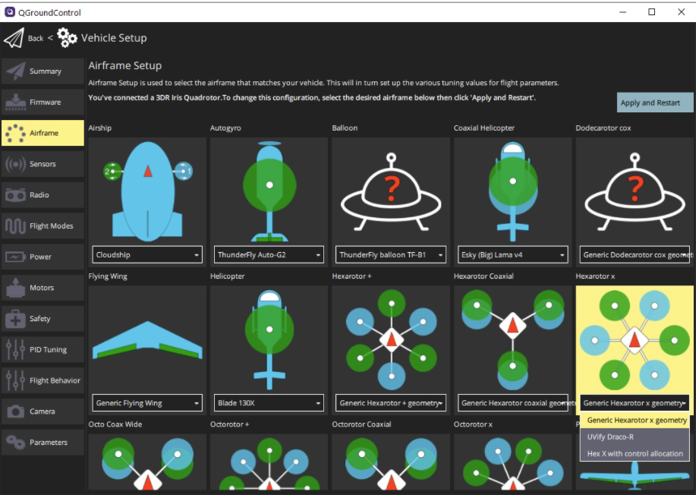

Figure 6.2

**CURRENTLY USING THIS AIRFRAME:**

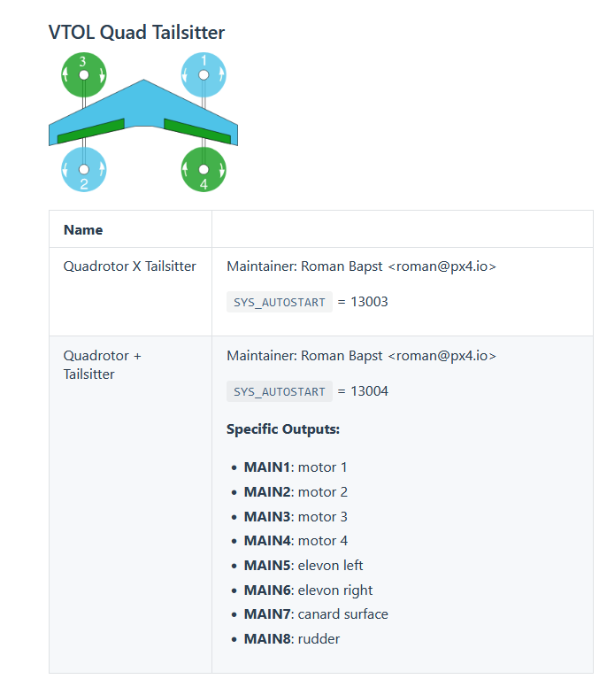

Once the airframe was selected, go to the tab on the left vertical bar labeled “Motors.”

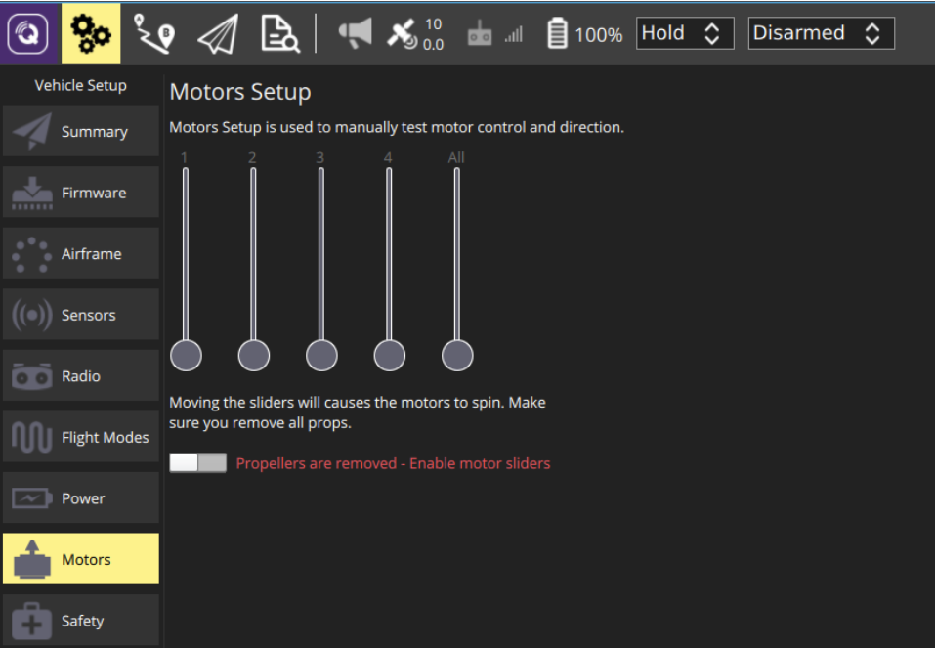

Figure 6.3

Make sure all propellers are removed. Then raise each slider approximately 1/3 of the available distance. Sliders used for the test will be 1,2,3,4. The PX4 software has built in delays, therefore, the motors will spin approximately 2 seconds after you have released the slider position. Repeat the process for the remaining motors.

# Setting up the RC Controller to control the motors

<https://docs.px4.io/master/en/config/radio.html>

RC Controller Model:

<https://www.frsky-rc.com/product/taranis-x9-lite-s/>

FrSky RX6R Documentation:

<https://www.frsky-rc.com/wp-content/uploads/Downloads/Manual/RX6R/RX6R%20ACCESS-Manual.pdf>

How to register:

Turn off all power, including battery

Put transmitter into REG mode

While holding down F/S button, plug battery

How to bind:

Same thing, do not hold F/S button + BIND mode instead of REG mode

MIXES on RC to bind channel 5 to arm switch

# VOXL Flight - Controller + Computer

Documentation: <https://docs.modalai.com/voxl-flight/>

Turn off pre-flight checks for compass (no internal compass on board): set **SYS_HAS_MAG to 0**

Turn off pre-flight checks for airspeed sensor (do not have one installed): set **FW_ARSP_MODE to 1**

**SET ACCELEROMETER AND MAGNETOMETER ORIENTATIONS:**

[**https://docs.px4.io/v1.12/en/config/flight_controller_orientation.html**](https://docs.px4.io/v1.12/en/config/flight_controller_orientation.html)

**How to perform ESC calibration:**

[**https://docs.modalai.com/flight-core-pwm-esc-calibration/**](https://docs.modalai.com/flight-core-pwm-esc-calibration/)

**Problem:**

<https://forum.modalai.com/topic/418/motors-not-responding-to-throttle/5>

* Likely need this to fix it:
  + <https://www.modalai.com/products/replacement-gps-mag-for-voxl-m500-pixhawk-4-secondary-gps>
    - will add compass and gps
* Otherwise, this would have to be changed in the firmware:
  + <https://github.com/modalai/ecl/commit/bbfc7a877b6a344ec6b3d57d164d160e22436495>
  + This also involves having vision setup with the VOXL board

There’s a default parameters file:

<https://docs.modalai.com/upload-px4-parameters/>

# Wireless Connection between QGC and VOXL

3 modes of wireless communication:

* **WiFi** (<https://docs.modalai.com/qgc-wifi/>)

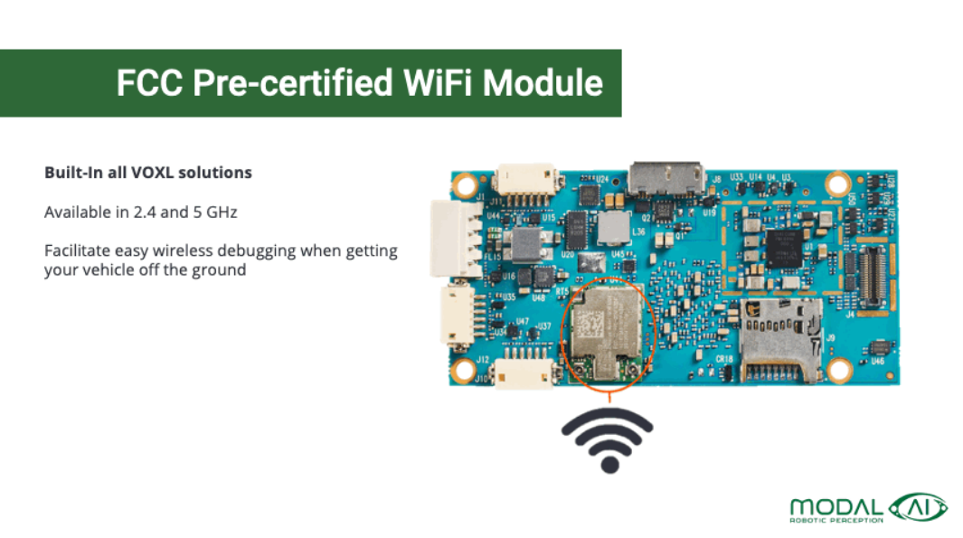

* LTE (<https://docs.modalai.com/voxl-lte/>)



* Microhard (<https://docs.modalai.com/microhard-add-on-manual/>)

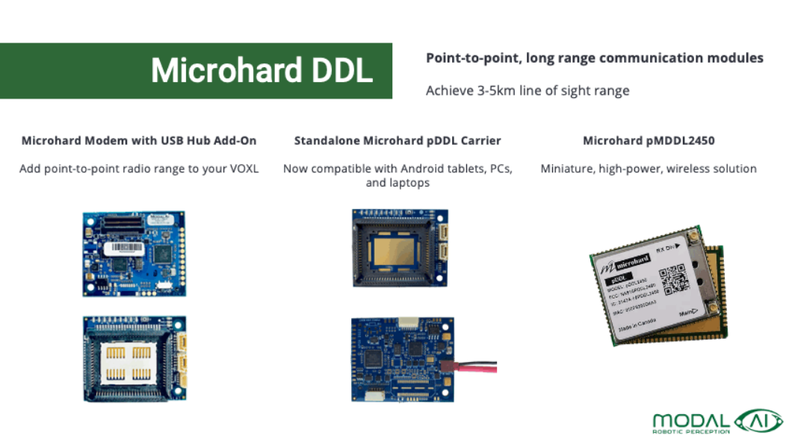

## WiFi Connection Process

QGC current version: v4.1.6 (needs to be at least v3.5.6)

How to get into voxl control menu:

ssh root@192.168.8.1

(password: oelinux123)

yocto: cd voxl-suite-ipk

**WIFI ADAPTER MUST HAVE THESE SETTINGS:**

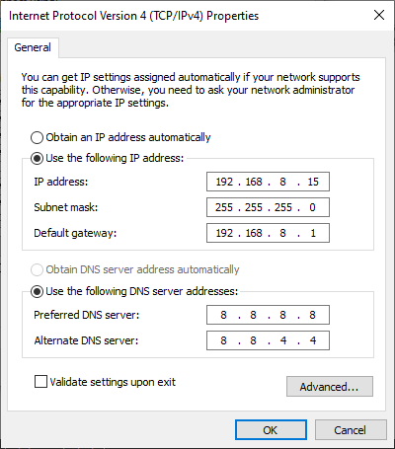

# Telemetry

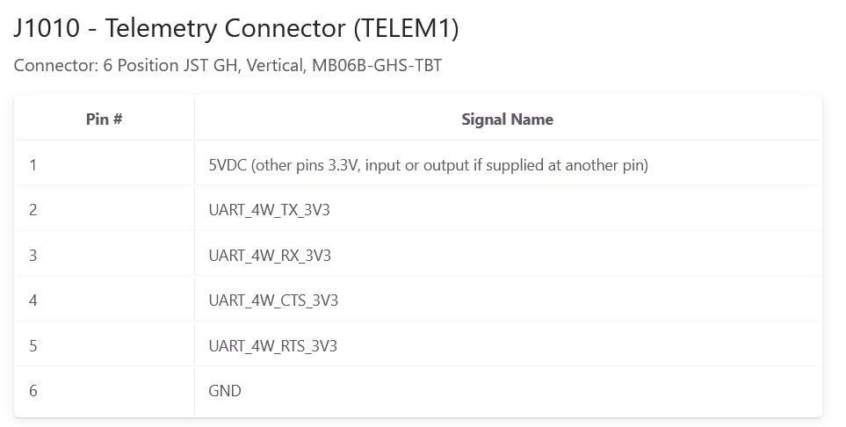

Connector: 6 Position JST GH, Vertical, MB06B-GHS-TBT

